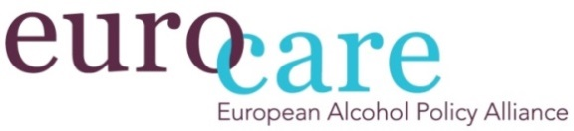
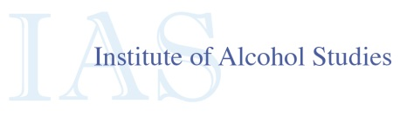
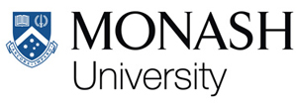

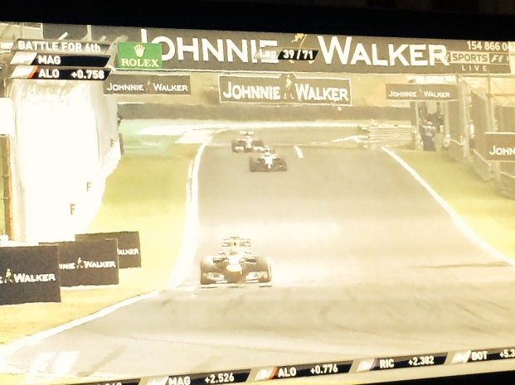
FACT SHEET
FORMULA ONE AND
ALCOHOL SPONSORSHIP

MAY 2015

Data on the exposure of alcohol brands in motorsport are now available. A new report by Eurocare together with Institute of Alcohol Studies and University of Monash presents alcohol exposure data drawn from the 2014 Formula One (F1) Monaco Grand Prix, as well as an analysis of alcohol related sponsorship within F1 teams. The findings show that alcohol sponsorship of F1 provides a platform for an extremely high exposure of alcohol brands for audiences.

During the Monaco 2014 F1 race we can see that there was an average of 11 references to alcohol brands per minute. In other words – the worldwide audience of 500 million people were exposed to an alcohol brand on average every five seconds for almost two hours.

ALCOHOL SPORTS SPONSORSHIP: CURRENT LANDSCAPE
Alcohol sponsorship of sport is a contested issue, with the major medical and public health institutions in Europe calling for a ban, similar to the ban on tobacco sports sponsorship. Alcohol companies currently sponsor several high profile tournaments including the FA, EUEFA and World Cups, Rugby Union and Formula 1, and concerns have been raised about the high volume of child viewers. Bans are in place in France and Norway, and the governments of Ireland and New Zealand are considering proposals.
FINDINGS FROM THE FREQUENCY ANALYSIS OF THE F1 GRAND PRIX MONACO 2014
During the F1 Monaco Grand Prix 2014, there were 1352 identified references to alcohol: 74 pre-race (0.8 per min, lasted 93 min), 1177 during the race (10.9 per min, lasted 109 min) and 77 post-race (0.9 per min, lasted 82 min).
The location of references during the race were track-side signage (1072), gantries (bridge over the track) (54) and on the car (48).
All references during the race were for spirits, predominately Johnnie Walker and Martini – placed strategically on locations with long exposure time.
Two important findings in the end: F1 racing has the highest level of alcohol brand exposure of any sports event reported in peer reviews literature, and spirit brands predominate.

FINDINGS FROM THE ANALYSIS OF ALCOHOL SPONSORSHIP OF F1 TEAMS
Three out of ten teams are clearly sponsored by alcohol companies: William Martini Racing (Martini), Force India (Smirnoff and Kingfisher) and McLaren Honda (Johnnie Walker).
The sponsor is highly visible on the driver and the car.
Drink-driving is not mentioned by two of the teams (Force India and Williams Martini Racing). The last team (McLaren Honda) has made a campaign for awareness on drink driving. However, when accessing this page it appears more as a branding exercise than awareness on the topic and is located on the brand’s Facebook page.

EU AUDIOVISUAL MEDIA SERVICES DIRECTIVE
The legal framework for advertisement in Europe, the EU Audiovisual Media Services Directive (AVMSD) acknowledges the importance of regulating alcohol advertisement, but is not responding satisfyingly to the issue of sponsorship. The sponsorship practices shown in this report clearly go against the spirit of the AVMSD. Furthermore, the practices in F1 also go against the existing voluntary codes set up by the industry itself.

IMPACT OF ALCOHOL MARKETING
There is strong and consistent evidence to show a link between exposure to alcohol marketing and increased alcohol consumption amongst young people: a number of systematic reviews have concluded exposure to alcohol advertising increases the likelihood that young people start drinking at an earlier age, and to drink more if they already use alcohol.

